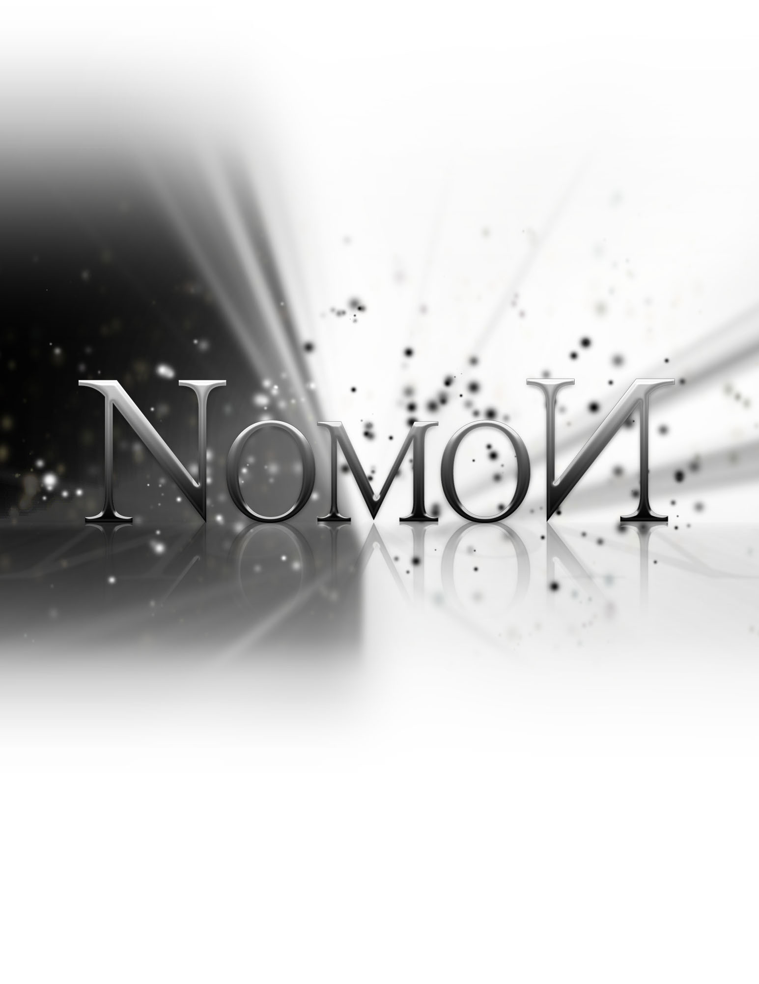
Status Report

Friday, December 2, 2011

Status Report

The List of Tasks to be done by this period:
  - Game Polishing & Level Building

Tasks underway:

Modelling - 95% Complete
Tom (5%), Sarah (10%), Shaughn (65%), Adam (15%)

Level Design – 90% Complete
Adam (50%), Nik (30%), Tom (10%)

Level Building - 65% Complete
Tom (30%), Nik (20%), Shaughn (15%)

Animation – 95% Complete
Sarah (90%), Shaughn (5%)

Promo Material – 66% Complete
Sarah (50%), Shaughn (16%)

UDK Custom Classes – 90% Complete
Tom (70%), Adam (10%), Shaughn (10%)

UDK Level Transitions – 60% Complete
Tom (30%), Sarah (30%)

Sound and Music – 20% Complete
Shaughn (20%)

Web Bug Fixes – 100% Complete
Adam (100%)

Particle Effects – 10% Complete
Shaughn (5%), Tom (5%)

UDK Custom Menus – 15% Complete
Sarah (15%)

We will need to implement the following functionality:
- Particle Systems: UDK has a rough particle system built-in but it needs to be adjusted to suit our game’s aesthetic
- Light Carrying: Line-of-sight must be incorporated to make certain game mechanics function more smoothly

We also need to finish building the levels, including adding pretty assets, play test the platforming physics, fine tune the lighting, implement the shaders and sound effects.

List of Tasks Accomplished by their appropriate date:

- Web Bug Fixes

List of delivered results of the tasks (files, etc)

- FBX – level assets
- UDK Files – custom classes, levels

Challenges and problems faced

Level Building Issues
There were several issues when it came to putting contents into the levels. Sometimes UDK crashed before important changes could be saved; other times, levels were being built incorrectly.

Solution: rebuild levels as necessary

